Types of Binary Attributes
Binary attributes can be of two main types:
- Symmetric binary attributes
  - Both values are equally important.
  - Example: Male/Female, Yes/No.
- Asymmetric binary attributes
  - The positive outcome (1) carries more importance than the negative (0).
  - Example: Medical test result (disease present = 1, absent = 0).

Name | Gender | Fever | Cough | Test1 | Test2 | Test3 | Test4
Jack | M | Y(1) | N(0) | P(1) | N(0) | N(0) | N(0)
Jim | M | Y(1) | Y(1) | N(0) | N(0) | N(0) | N(0)
Mary | F | Y(1) | N(0) | P(1) | N(0) | P(1) | N(0)
(Assumption: Y/P = 1 (positive/present), N = 0 (negative/absent))

Step 1. Compare Patients
We will compute symmetric and asymmetric binary dissimilarities between patients.

🔹 Case 1: Jack vs Jim
Jack = [1, 0, 1, 0, 0, 0]
Jim = [1, 1, 0, 0, 0, 0]
- (a) = both 1s = Fever only → 1
- (b) = (Jack=1, Jim=0) → Test1 → 1
- (c) = (Jack=0, Jim=1) → Cough → 1
- (d) = both 0s → Test2, Test3, Test4 → 3
So: (a=1, b=1, c=1, d=3).
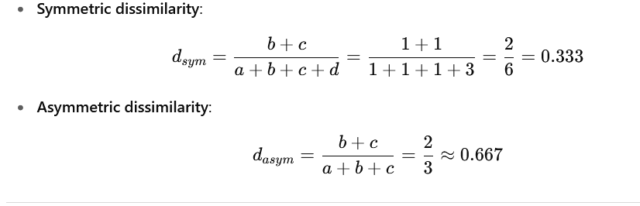
🔹 Case 2: Jack vs Mary
Jack = [1, 0, 1, 0, 0, 0]
Mary = [1, 0, 1, 0, 1, 0]
- (a) = Fever, Test1 → 2
- (b) = (Jack=1, Mary=0) → none → 0
- (c) = (Jack=0, Mary=1) → Test3 → 1
- (d) = both 0s → Cough, Test2, Test4 → 3
So: (a=2, b=0, c=1, d=3).
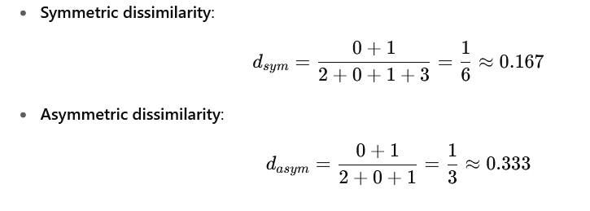
🔹 Case 3: Jim vs Mary
Jim = [1, 1, 0, 0, 0, 0]
Mary = [1, 0, 1, 0, 1, 0]
- (a) = Fever only → 1
- (b) = (Jim=1, Mary=0) → Cough → 1
- (c) = (Jim=0, Mary=1) → Test1, Test3 → 2
- (d) = both 0s → Test2, Test4 → 2
So: (a=1, b=1, c=2, d=2).
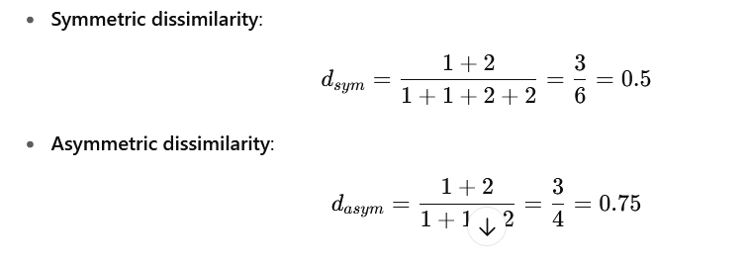
✅ Final Results
Pair | Symmetric Dissimilarity | Asymmetric Dissimilarity
Jack vs Jim | 0.333 | 0.667
Jack vs Mary | 0.167 | 0.333
Jim vs Mary | 0.500 | 0.750

